EXPERIMENT 1
OHM’S LAW
Aim: To find the resistance per unit length of a given wire, by plotting graph between potential difference and current.
Theory:
V α I or V= IR

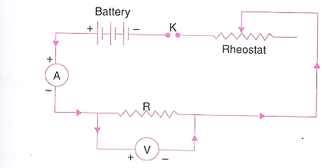
Circuit Diagram:

Observations:
Sl. No | Voltage (V) Volts | Current (I)  Ampere | Resistance (R)  Ω
01
02
03
04
05
Mean Resistance of the given wire = Ω
Length of the given wire = cm
Resistance per unit length = Ω/cm
(Graph)

Result: The graph between V and I is a straight line.
Resistance of the given wire = Ω/cm

