Sharjah Indian School – Boys Wing
Extra questions on ‘Communication Systems’ – Class XII
1.
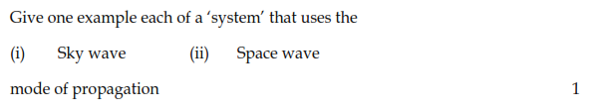
2.

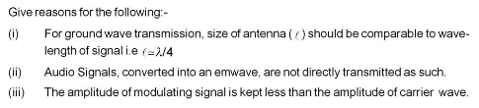
3.

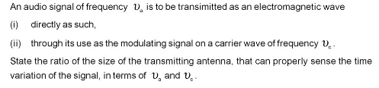
4.

5.

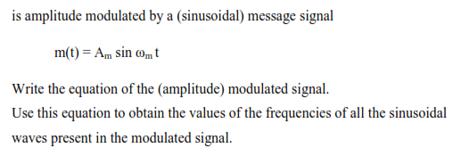

6. Name the computer that extracts signals from the server.
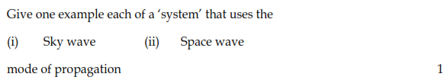
7.

8.
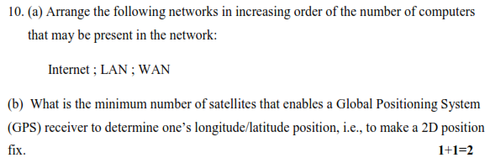
9. Mention any three applications of GPS.

11. Describe how does a GPS identifies a specific location.
12. Why is mobile phone network also called ‘terrestrial cellular network’?
13. What is the merit of ‘3G’ over ‘2G’?
14. 4G would be a revolution in the field of mobile communication. Explain.
15. Explain the working principle of mobile phones.

